

# CS 305 Project Two

**Practices for Secure Software Report**

**Christopher Dewey**

**June 13, 2022**

Table of Contents

Document Revision History 3

Client 3

Instructions 3

Developer 4

1. Algorithm Cipher 4

2. Certificate Generation 4

3. Deploy Cipher 4

4. Secure Communications 4

5. Secondary Testing 4

6. Functional Testing 5

7. Summary 5

## Document Revision History

| **Version** | **Date** | **Author** | **Comments** |
| --- | --- | --- | --- |
| **1.0** | **06/13/2022** | **Christopher Dewey** |  |

## Client



## Developer

Christopher Dewey

## 1. Algorithm Cipher

**Asymmetric & Symmetric Encryption**

Once a secure connection between client and server is established through TLS/SSL, the AES 256 encryption cipher will be used to secure communications during the session. The three-way TLS handshake is initialized when the client requests communication with the web server. Upon receiving that request, the server will respond by sending its SSL certificate back to the client. The client’s browser will validate this SSL certificate by comparing its hash value with one stored in the browser. (Given that it is a self-signed certificate.) If this hash value (digest) does not match, it is possible that the certificate has been tampered with. Following the validation of the certificate, the client and server will each use RSA asymmetric encryption (the TLS 1.3 standard) to exchange public keys. Following packet acknowledgement, the server can finally securely share the AES 256 key with the client so future communications during this session can be encrypted and decrypted with the same key, preventing malicious actors from intercepting sensitive plaintext. (LuxSCI, 2020)

**Security**

The AES 256 encryption block cipher is the financial industry standard. In addition to the financial industry, AES 256 is also trusted to encrypt government and military communications! Symmetric encryption performs faster and uses less compute resources when compared to asymmetric encryption ciphers of similar security levels.

**Asymmetric Cipher & Hash Function**

The RSA asymmetric encryption cipher will be used in the TLS key exchange to securely share the AES 256 key. SHA2-256 is a hash function allowing client browsers to check certificate validity and verify checksums (digests) of downloaded files for integrity. SHA is also used to hash passwords prior to storing in a database. In the unlikely event that the database is compromised and decrypted, passwords are shown as digest instead of plaintext. To prevent brute force attempts to match a password to its hash (Rainbow Table Attack), passwords are should be salted by algorithmically adding a mix of pseudo-random numbers. This practice does not add considerable resource overhead when used appropriately and the security benefits make it a must to protect user credentials.

**Key Length**

A 256-bit key is longer than a 128-bit key, making the encryption more secure to brute force attempts to guess the correct key. With enough computing power and time, a brute force attack can ultimately find the correct key, but this can take such a long time that by the time the key is found, a new session and key has already been shared invalidating the previous key. Compared to a 128-bit key, a 256-bit key is double the size. A 256-bit key is considerably more than twice as secure as a 128-bit key, however. Not only do the possible combinations increase exponentially, but time to calculate a match in a brute force attack more than doubles as well.

**History**

AES 128 has been used with great success and is currently considered secure against modern technology. Using AES 256 to safeguard against future technological advancement is worth the small increase in compute time and resources needed for encryption and decryption when compared to AES 128. Although still in its infancy, regular advancements quantum computing has created concerns for modern cryptography. The AES 256 algorithm is anticipated to remain secure for a very long time, unlike other cryptographic methods, such as Diffie-Hellman Key Exchange, RSA, and TLS, which are presumably threatened by quantum computers. (Copeland, 2021)

Many encryption algorithms have been deprecated and are no longer secure due to the rise in compute power and/or as mathematical solutions crack the cipher. Perhaps the most well known is the Caesar Cipher, one of the earliest cryptographic solutions that simply shifted letters in the alphabet. Another famous obsolete encryption algorithm, Enigma, allowed Nazi Germany to send scrambled messages. Helping end WWII, Alan Turing cracked the Enigma code alongside his team in 1940! (Hodges, 1983)

## 2. Certificate Generation

Figure 2 (below) shows the self-signed certificate created for use during development. Under the certificate fingerprints, the SHA2-256 (SHA256) digest is displayed. The Owner and Issuer fields show the information inputted during the certificate’s generation through the Java Keytool.

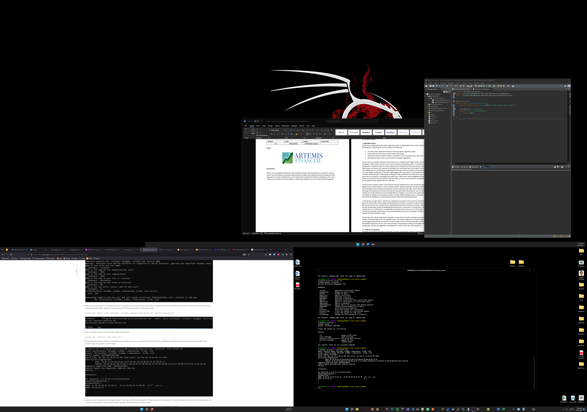

Figure 2

Note: Once deployed to production, self-signed certificates are not feasible. Using a reputable certificate authority for the generation of our SSL certificates allows client browsers to validate the authenticity of the certificate by checking with a trusted authority. This is completed within the client’s browser. A self-signed certificate will prompt users with a security warning message.

## 3. Deploy Cipher

Figure 3 (below) shows the SHA2-256 checksum. This demonstrates the successful deployment of the hash function that can be used to validate downloaded files and protect passwords from being stored as plaintext.

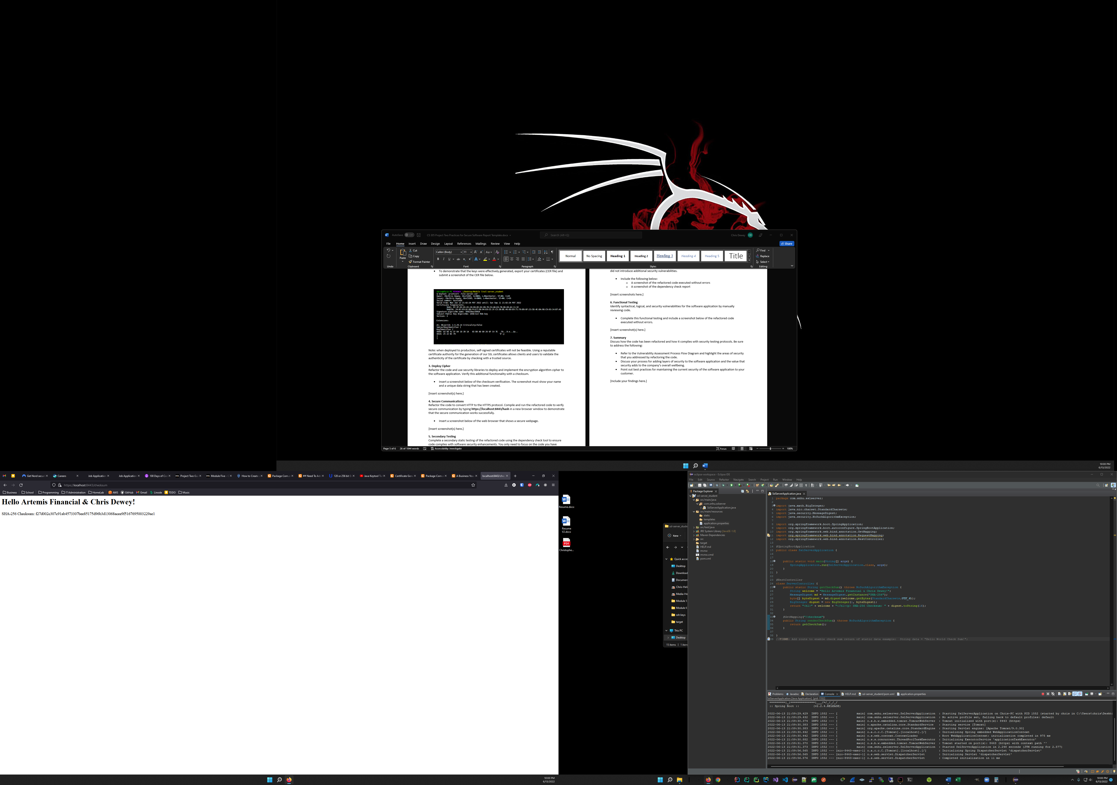

Figure 3

## 4. Secure Communications

Figure 4.1 (below) demonstrates an HTTPS connection has been made successfully. Navigating to <https://localhost:8443/hash> will force HTTPS, prompt a TLS handshake, and encrypt future traffic. The lock icon in the address bar has a small warning flag to identify a self-signed certificate security exception has been made. Upon first visit, the browser will warn users that the site does not have a verifiable SSL certificate since it is not signed by a trusted certificate authority. This is to be expected in our development environment. In production, once a trusted certificate authority’s signed SSL certificate is implemented, this security exception and subsequent warning flag are removed.

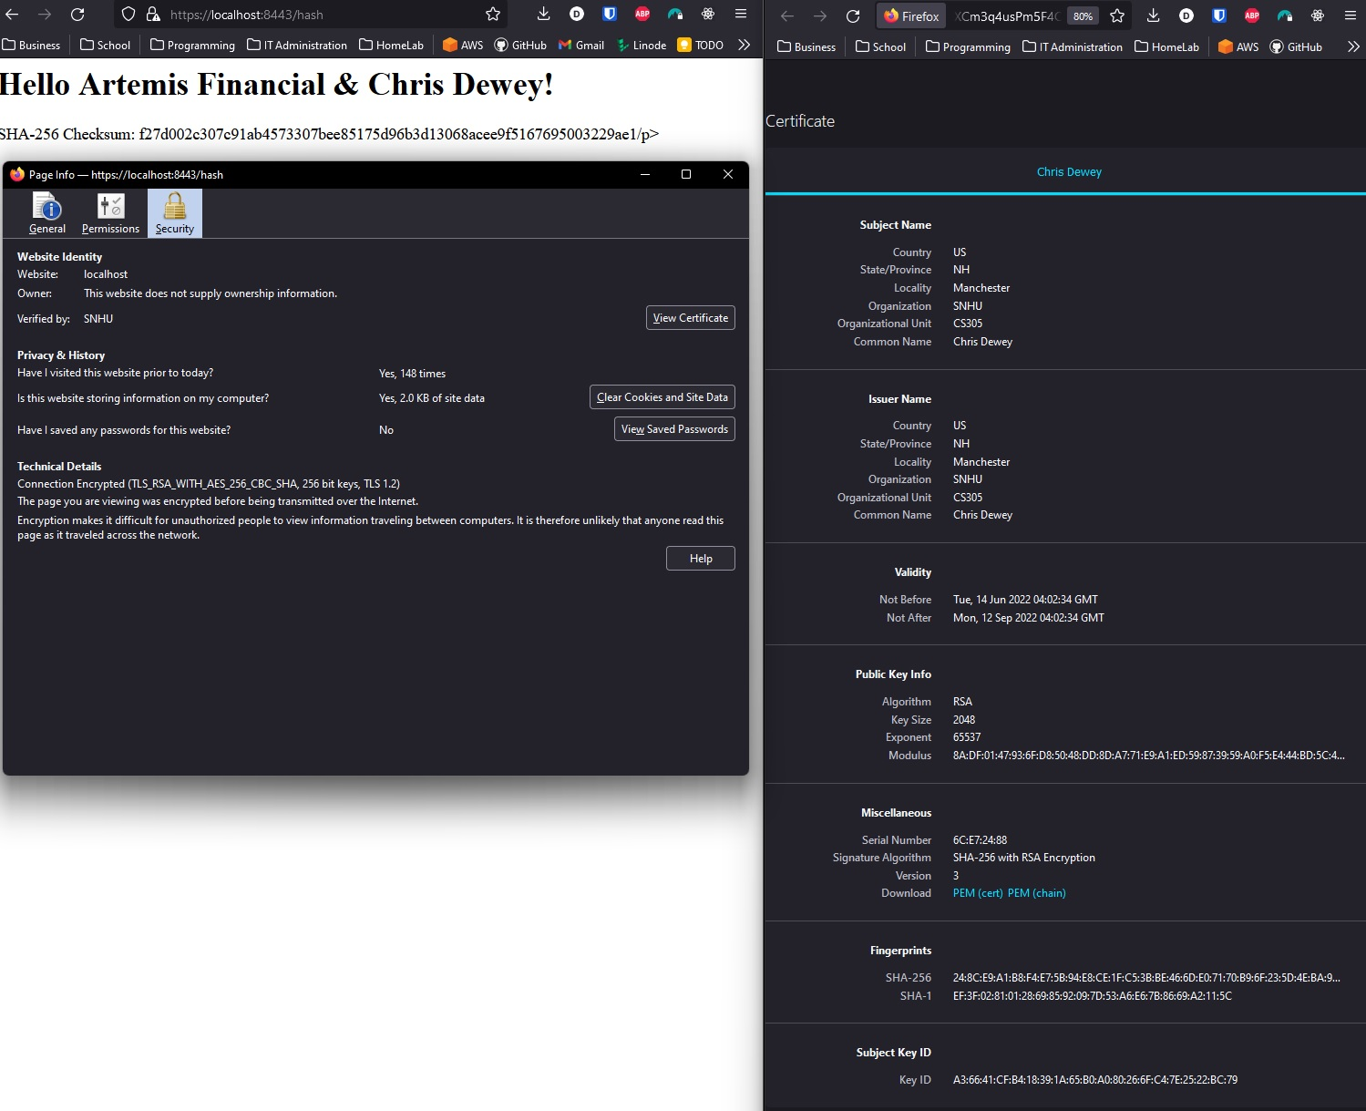

Figure 4.1

Figure 4.2 (page 6) provides a closer examination of the self-signed certificate created through the Java Keytool. During the certificate’s creation, RSA 2048-bit public and private keys are generated. The public key gets injected into the certificate and the private key is stored securely, accessible only by the server. By specifying SHA256withRSA, the certificate is signed with a SHA256 hash digest.

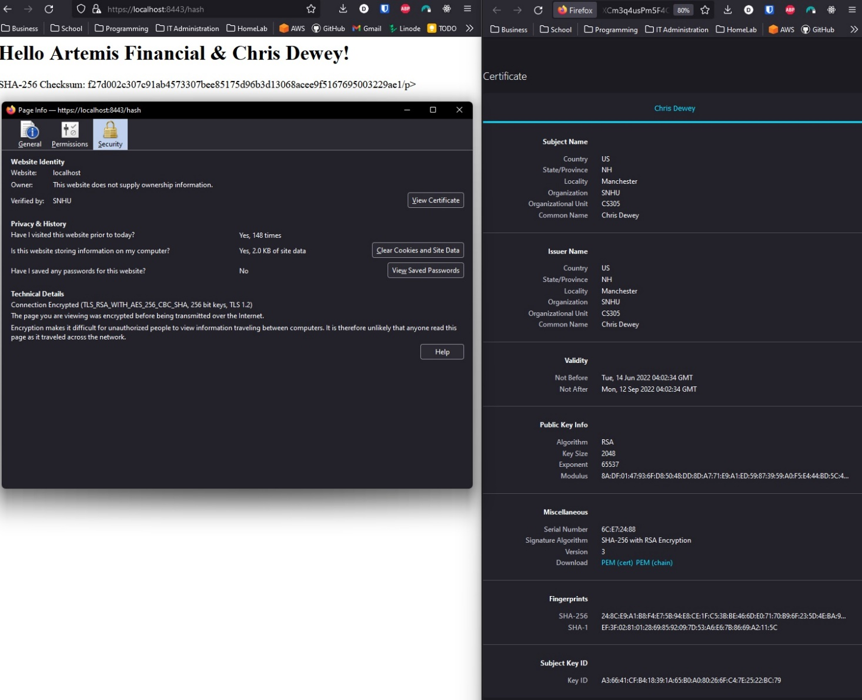

Figure 4.2



Figure 4.3

During the TLS handshake, the client’s browser is forced to use AES 256 through server-side rules. Using Spring, these rules are kept in a secure file called application.properties. (Figure 4.4, below) This file also sets listening the listening port to 8443 to force use of secure protocols. In the browser, the session’s TLS requirement, asymmetric encryption cipher for exchanging session key (RSA), and symmetric encryption cipher (AES 256), key size (256-bit), and connection protocol (TLS 1.2) are identified under Technical Details within Page Security Information. (Figure 4.3, above)

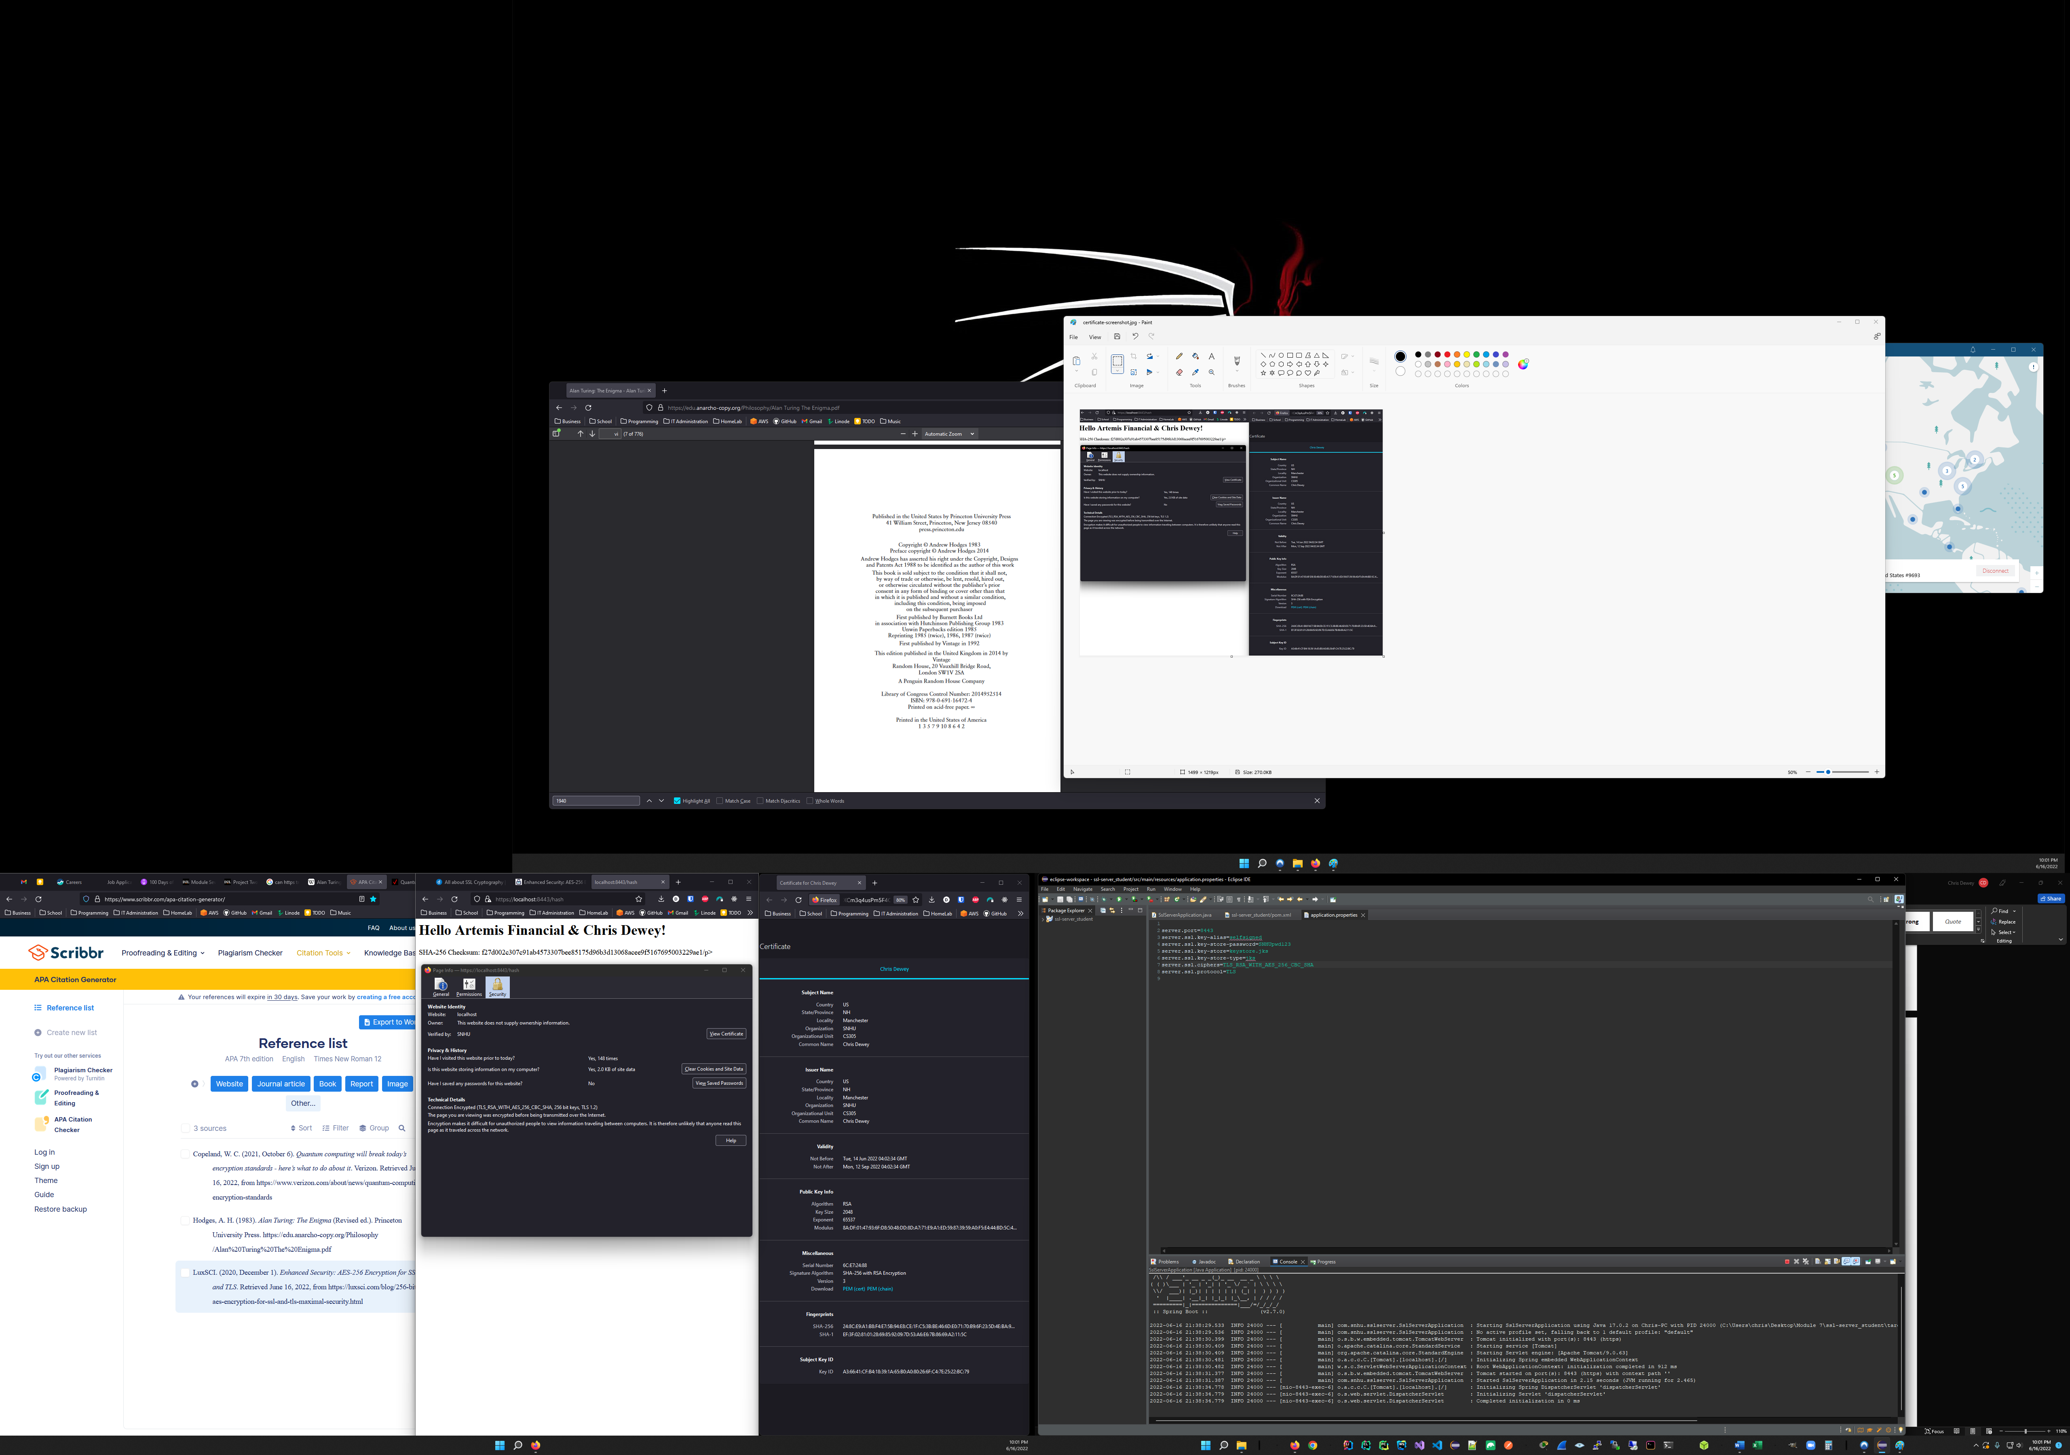

Figure 4.4

## 5. Secondary Testing

Prior to refactoring code, the OWASP Dependency check tool found 13 vulnerable dependencies and 57 vulnerable dependencies. Following refactoring, rerunning the Dependency Check returns the same number of vulnerabilities and vulnerable dependencies.

* Figure 5.1 shows the refactored code running without errors:

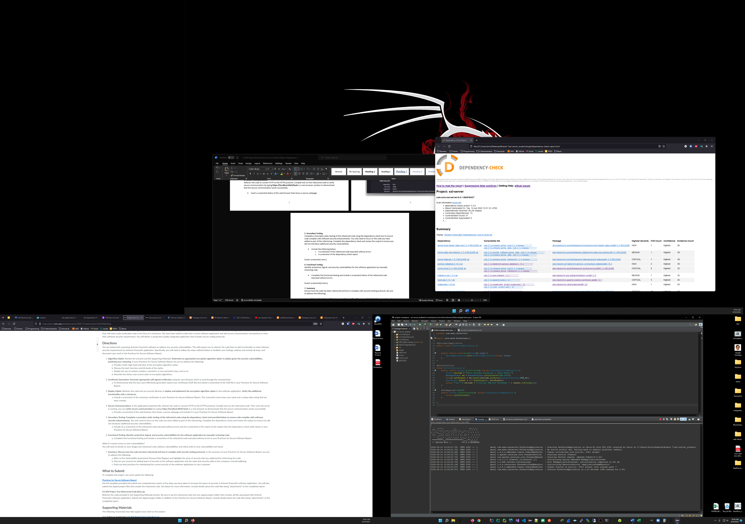

Figure 5.1

* The OWASP dependency check results after refactoring code to add SSL/TLS configurations, certificate, and configuration for use on port 8443 is shown in Figure 5.2, below. No new vulnerabilities were introduced.



Figure 5.2

## 6. Functional Testing

Identify syntactical, logical, and security vulnerabilities for the software application by manually reviewing code. (See Figure 6, below)

* The code executed previously without errors or new vulnerabilities. Comments have been added for readability and future updates/maintenance/testing.
* A few files were added to the project during the creation of the security certificates during testing and have been removed to reduce clutter. These files were to test AES 256 encryption. A second keystore and certificate were removed, leaving the relevant files intact.
* Spring Boot Starter Parent was using version 2.2.4, which has been superseded by version 2.7.0.
* The OWASP Dependency Check tool was using 5.3.0, which has been superseded by version 7.1.1. This is unlikely to cause any issues other than vulnerability detection refinement.
* Rerunning a Dependency check after updating these dependencies results in one unique remaining vulnerability, CVE-2016-1000027. This has been reported by Spring as a false positive.
* Suppressing this pesky false positive results in zero new vulnerabilities found.
* As future dependencies are added, careful consideration to their respective versions and vulnerabilities must be made.

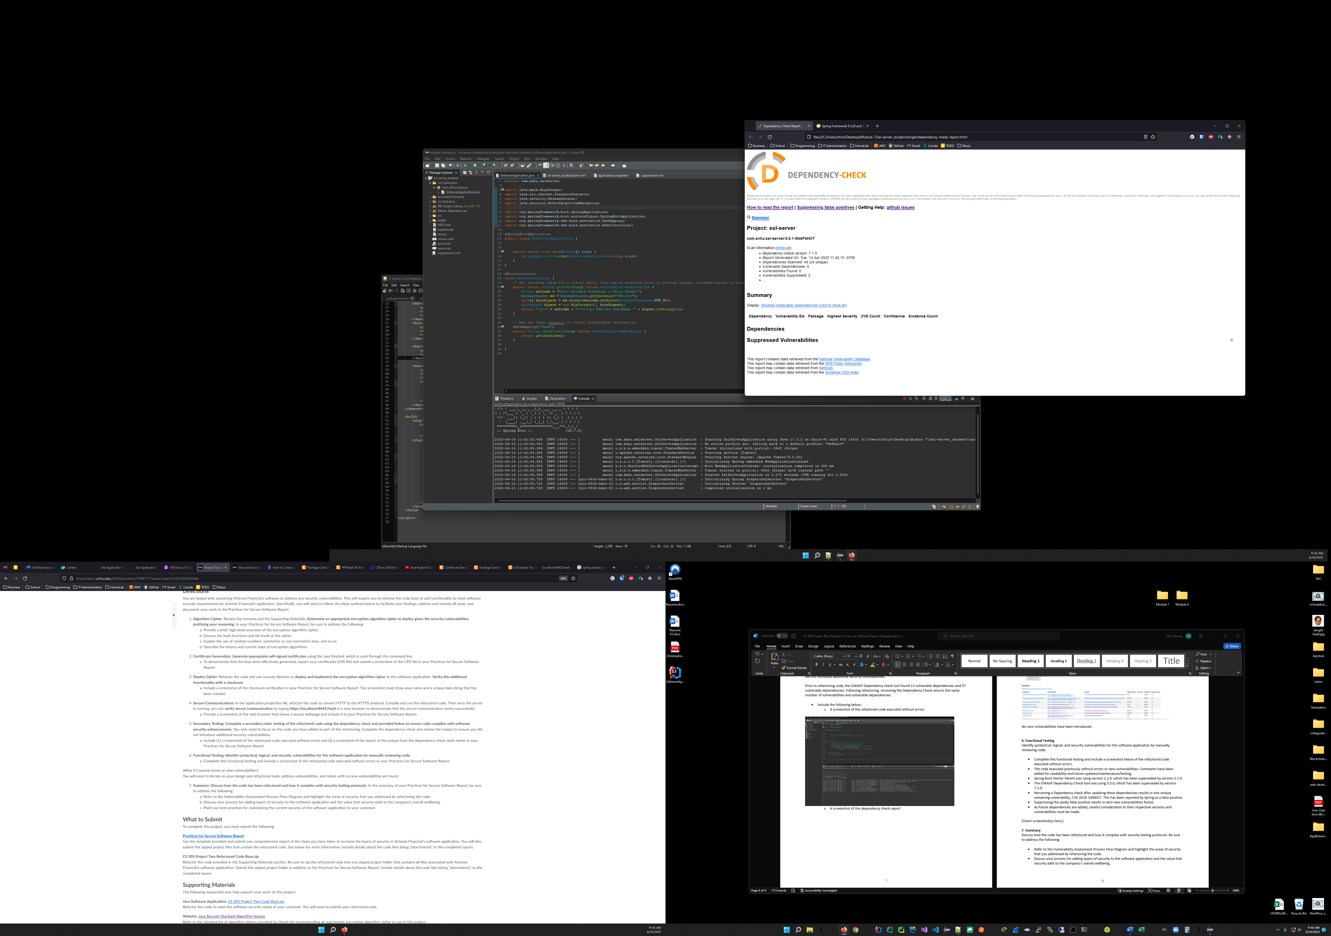

Figure 6

## 7. Summary

**Vulnerability Assessment Process Flow**

* In the application’s current configuration, no Input Validation is needed. As future enhancements are made and input is accepted, validation to reduce risks of injection attacks, prevent prying eyes from seeing sensitive data in fields such as passwords, and proper entries are made into each field will enhance client experience and reduce software security risks.
* Aside from the integration of the Spring dependencies and some testing methodologies, no API interactions are currently being utilized.
* No database has been implemented yet. Once a database is implemented, API interactions and encryption methodologies must consider both data in transit and data at rest. Passwords and other non-retrievable data should use hashing and salting methods to prevent rainbow table attacks in the event the database is compromised. This also prevents employees with access to the database from uncovering user passwords. Encrypting the data in the database and preventing direct user interactions with the database will eliminate data integrity concerns.
* Client and server interactions are secured through SSL/TLS and a self-signed certificate. Traffic is protected and secured by being forced to use TLS/SSL protocols via port 8443. Upon completion of the three-way handshake, future traffic in that session is encrypted, preventing man-in-the-middle attempts to intercept plain-text data.
* At the moment, since the application does not have any features other than providing a static checksum, no error reporting is performed. Once additional functionality is implemented, error logging and handling must not be extractable client-side without proper authentication and authorization.
* Encapsulation, encryption, and securing traffic between the web server and the database will be critical to Artemis’ compliance requirements and to protect internal data along with user privacy.

**Self-Signed Certificate**

In a testing environment, using self-signed certificates for SSL/TLS is adequate, but once the application is pushed to production, (as mentioned previously) using a trusted certificate authority for the issuance of SSL certificates will be paramount to prevent site/DNS hijacking, and to be able to validate the authenticity and integrity of the web server.

**Dependency Vulnerabilities & False Positives**

Currently, there are no known dependency vulnerabilities aside from some false positives. These false positives have been suppressed, but as time passes, new vulnerabilities are made known and additional dependencies and integrations are added, regular security evaluations, static testing, and manual testing should be performed before making new iterations available to production.

**Other Security Considerations**

Redundancy and networking considerations, including using multiple availability zones, load balancers, content delivery networks, and instances will prevent risks of downtime and DDoS attacks. To conform to compliance regulations, it may be required that on-prem managed servers or dedicated servers are used to host financial institution data. Mirroring these servers across multiple regions to reduce environmental risks, such as power outages, natural disasters, and isolated security incidents helps to protect and secure data and reduce possibilities of downtime.

**Scaling & Future**

As traffic, functionality, dependencies, integrations, and storage grows, compute needs and network traffic can grow exponentially, proper scaling plans and business/cost analyses must take place prior launch. Lastly, security considerations do not stop here. Implementing internal DevSecOps teams for the ongoing development, management, and incident response needs alongside constant compliance monitoring is necessary for any financial institution offering digital services. Proper security implementation involves physical, network, software and cybersecurity initiatives. Producing and maintaining a secure application involves much more than code!

Works Cited

Copeland, W. C. (2021, October 6). *Quantum computing will break today’s encryption standards - here’s what to do about it*. Verizon. Retrieved June 16, 2022, from https://www.verizon.com/about/news/quantum-computing-encryption-standards

Hodges, A. H. (1983). *Alan Turing: The Enigma* (Revised ed.). Princeton University Press. https://edu.anarcho-copy.org/Philosophy/Alan%20Turing%20The%20Enigma.pdf

LuxSCI. (2020, December 1). *Enhanced Security: AES-256 Encryption for SSL and TLS*. Retrieved June 16, 2022, from https://luxsci.com/blog/256-bit-aes-encryption-for-ssl-and-tls-maximal-security.html